**Heavy industry input to the Sectoral Emissions Reduction Strategies**

**Questionnaire**

**Peak Industry Bodies and Industry Groups**

September 2022

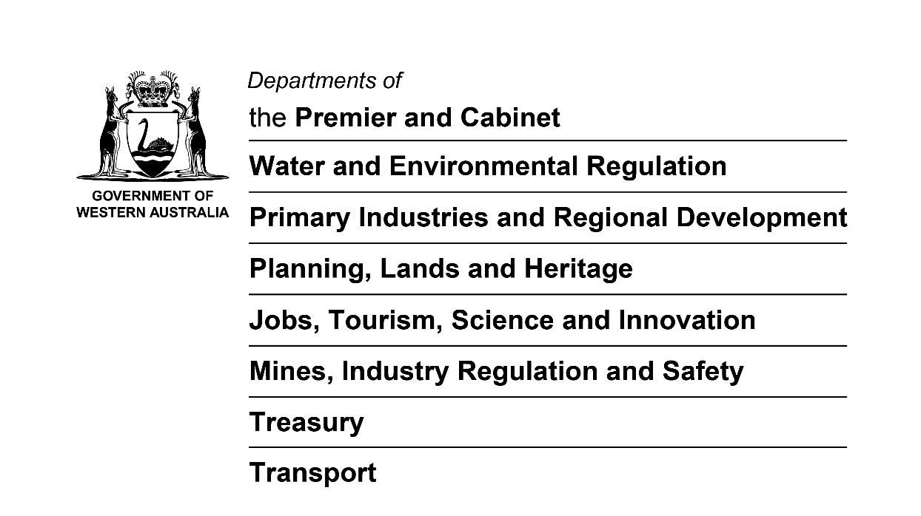

**INTRODUCTION**

**The Sectoral Emissions Reduction Strategies**

The Western Australian Government has committed to working with all sectors of the economy to achieve net zero emissions by 2050.

The development of sectoral emissions reduction strategies (SERS) aligned with this goal is a core commitment of the Western Australian Climate Policy.

The SERS process is expected to conclude by the end of 2023.

Objectives of the SERS

* To provide robust and credible emissions reduction pathways for Western Australia with tangible actions for reducing emissions consistent with the Western Australian Government’s target of net zero emissions by 2050.
* To recognise the importance of significant action this decade to reduce emissions, transition emissions‑intensive industries and protect Western Australia’s economy from carbon transition risks.

Supporting heavy industry sectors to decarbonise will be key to achieving significant emission reductions in Western Australia and ensuring the State’s economy benefits from the transition to net-zero by 2050.

Policy options and initiatives to support emissions reduction by industry will be investigated as part of the SERS.

The approach to policy development under the SERS will be compatible with and complementary to the Australian Government's climate change commitments.

Governance

The Department of Water and Environmental Regulation (DWER) is the lead agency for the SERS in collaboration with key State Government agencies.

The Department of Jobs, Tourism, Science and Innovation (JTSI) is responsible for heavy industry consultation and the delivery of the heavy industry component of the SERS.

Energy Policy WA (EPWA) in the Department of Mines, Industry Regulation and Safety is responsible for the delivery of the electricity component of the SERS and the South West Interconnected System Demand Assessment (SDA).

EPWA, DWER and JTSI are working together to align the industry consultation processes as far as practicable and minimise duplication.

**Heavy industry input to the SERS**

The SERS aims to reduce barriers to decarbonisation and support and facilitate the transition of Western Australia’s heavy industries to net-zero, reflecting the importance of Western Australia’s heavy industry sector to the state’s economy.

Collaboration and partnership with heavy industry is critical to the success of the SERS.

In order to understand challenges and opportunities for emissions reduction, the Government is coordinating sectoral and whole of economy modelling to develop a view of projected emissions in Western Australia over the next decade based on industry plans and commitments, and credible emissions pathways to net zero emissions by 2050.

Input by heavy industry is critical to ensure emissions projections and analysis is robust and informed by industry action and expectations. This analysis and the actions arising from the SERS will help to ensure that Western Australian business and industry is adequately prepared for the net zero transition. Consultation and analysis conducted for the SERS will assist the Government to understand: infrastructure requirements; training and workforce requirements; fuel and low emissions technology needs; areas of focus for research and development; and associated enablers and barriers to action.

The net-zero transition will support the diversification of our economy, help attract new investment, boost WA’s competitiveness and strengthen the State’s ESG credentials.

**Heavy industry input to the electricity modelling**

Electricity modelling is being undertaken to inform the SDA and the SERS.

The Western Australian Government is collecting information for:

* The South West Interconnected System (SWIS)
* The North West Interconnected System (NWIS) and the Pilbara, off-grid supply and Horizon Power towns

The electricity modelling will enable the Government to form a consolidated view of future renewable energy needs, network infrastructure, and requirements for a secure and reliable electricity system.

Input to the SWIS Demand Assessment (SDA)

The Western Australian Government has committed to a fast-tracked assessment of future demand for renewable energy on the SWIS.

EPWA will be contacting the largest energy users directly as part of the SDA during September 2022.

Updates on the SDA are available here: <https://www.wa.gov.au/government/announcements/swis-demand-assessment>

Input to the NWIS, Pilbara grids and off-grid electricity modelling

To assess future demand for renewable energy, EPWA will engage in discussions with the heavy industry and other electricity users during September and October 2022.

**questionnaire**

**Objective**

Information sought through this questionnaire, and, where relevant, through follow up interviews with peak industry bodies and industry groups, will provide key inputs to Government modelling and deliver insights into important trends, barriers and opportunities for heavy industry decarbonisation in Western Australia.

Input to this questionnaire, alongside information sought through the SDA and the electricity modelling for other parts of the State, will inform the development of possible new policy and initiatives to support industry decarbonisation.

**Scope**

This questionnaire is intended to capture information on current industry decarbonisation plans, as well as barriers to action and future opportunities for Western Australian operations.

For the purpose of the SERS, heavy industry includes:

* mining and mineral processing (e.g. iron ore, alumina, gold)
* petroleum operations (oil and gas production and exploration)
* manufacturing (e.g. cement, ammonia, fertiliser)

**Process**

As a first step, we are seeking heavy industry’s input:

* to understand heavy industry emissions reduction targets and goals
* to investigate the barriers industry is facing to decarbonise
* to identify measures the Western Australian Government could consider to remove these barriers.

**Confidentiality**

Information provided by entities completing this survey will only be used for the purposes outlined above. Information will be treated confidentially and will be bound by Cabinet in Confidence provisions which protects its use. Data will be aggregated so as not to identify individual companies or facilities.

**Next steps**

Peak industry bodies and industry groups will be contacted in coming months for one-on-one consultation about the SERS.

Updates on the SERS development will be provided regularly on the Western Australian Government’s website at: <https://www.wa.gov.au/service/environment/environment-information-services/sectoral-emissions-reduction-strategies>

**Other consultation**

A number of key complementary processes relevant to heavy industry decarbonisation are underway, including:

* [Safeguard Mechanism reform: consultation paper](https://consult.industry.gov.au/safeguard-mechanism-reform-consultation-paper) (Australian Government)
* [Consultation on the Draft Revised Environmental Factor Guideline – Greenhouse Gas Emissions (GHG EFG)](https://www.epa.wa.gov.au/policies-guidance/environmental-factor-guideline-%E2%80%93-greenhouse-gas-emissions-0)
* [Greenhouse Gas Storage and Transport Bill](https://www.mediastatements.wa.gov.au/Pages/McGowan/2022/03/Draft-Bill-to-help-WAs-resources-industry-reduce-emissions.aspx)
* [Global Advanced Industries Hub](https://www.investandtrade.wa.gov.au/opportunities/global-advanced-industry-hub)
* [LNG Jobs Taskforce technology and decarbonisation working group](https://www.wa.gov.au/organisation/department-of-jobs-tourism-science-and-innovation/the-western-australian-lng-jobs-taskforce-working-groups#:~:text=The%20Technology%20and%20Decarbonisation%20Working,decarbonisation%20of%20the%20LNG%20sector.)

The Western Australian Government is seeking to reduce duplicative consultation where possible.

Consultation is also underway for other sectors of the SERS. Information on these processes can be found on the Government’s SERS webpage as noted above in Next Steps.

**To provide your input, please complete the questionnaire below and send your response via email by 28 October 2022 to:**

Estelle Roux

Director Climate Industry Action, Strategic Policy

Department Jobs, Tourism, Science and Innovation

E: [ClimateIndustryAction@jtsi.wa.gov.au](mailto:ClimateIndustryAction@jtsi.wa.gov.au)

P: 6277 3071

Contents

1 Your organisation

2 Industry position – emissions reduction goals, barriers and opportunities

ATTACHMENTS

# 

# Your organisation

**Organisation name:**

**Key contact details:**

## In which sub-sector of the heavy industry do your members mostly operate?

Mining or mineral processing

Petroleum operations

Manufacturing

## In what part of the State do your members operate? Please specify the Strategic Industrial Area/s if applicable.

Pilbara

Port Hedland

Burrup Peninsula

Karratha

Other:

Perth and Peel

Kwinana industrial area

Rockingham Industry Zone

Latitude 32

The Australian Marine complex

Other:

South West

Collie area

Other:

Gascoyne

Mid West

Wheatbelt

Great Southern

Goldfields-Esperance

Kimberley

## Do you have a policy position on climate change or energy? If yes, please provide a copy in attachment.

# Industry position – emissions reduction goals, barriers and opportunities

*(Please specify the sub-sector (Mining or mineral processing, Petroleum operations or Manufacturing)*

## What are the key operations, processes, or supply chains your members have identified as the most challenging to decarbonise?

## Are your members considering options to encourage or specify emissions requirements for supply chains that support your industry? Please detail.

## Are you on behalf of your members undertaking or investigating any collaborative activities for decarbonisation? Please detail.

## What are your members’ key drivers for emissions reduction?

## What are likely to be your members’ priority options for decarbonisation over the short-term (2030 horizon) and long-term (2050 horizon)?

|  |  |  |
| --- | --- | --- |
| **Priority option** | **Time Horizon** | |
| **2030** | **2050** |
| **Electrification** | *e.g. 1st priority* |  |
| **Energy efficiency** | *e.g. 2nd priority* |  |
| **Fuel switching** |  |  |
| **CCS / CCUS** |  |  |
| **Hydrogen** |  |  |
| **Offsets** | *e.g. 3rd priority* |  |
| **Other (please specify)** |  |  |

## What are the key barriers your members have identified to substantially decarbonising their operations (e.g. policy; regulation; partnerships/collaboration; markets; supply chains; technology availability and costs etc.)? Please outline the identified barriers against the topics below (as relevant).

**EMISSIONS REDUCTION**

### Electrification and energy storage

### Energy efficiency

### Gas demand

### Hydrogen

### Transport and fuel

### Carbon capture and storage and/or carbon capture, utilisation and storage (CCS/CCUS)

### Carbon offsets

### New and emerging industry development

**CROSS CUTTING ENABLERS**

### Land access

### Science and technology

### Workforce and skills

### ESG and investment attraction

### Other barriers?

## Do you have any data or modelling you could share in confidence?

## What measures could Government/s consider to address these barriers?

# ATTACHMENTS

Please include any relevant analysis you may wish to share with the Western Australian Government in confidence.

Please also include any additional information you would like to provide.